1.6 Theoretical Framework
1.6.1 Definition of Onsite Childcare Center
Due to demographic changes in the work force, the welfarist approach to human-resource management has resurfaced. In the past, benefits to individual workers were emphasised; today, family provisions are the centerpiece of the new corporate welfarism. Although employer-supported childcare and family leave characterize contemporary corporate welfarism, most research has focused only on employer-supported childcare. Friedman (1986) cites figures suggesting that childcare is becoming a major employee benefit. In the late 1980s, over 3,500 major companies in the United States offered some form of child-care support to employees (Edgar, 1988); 775 of these companies supported on-site child-care centers (Brandon & Temple, 2006).
An on-site ESCC facility can be regarded as one type of ‘family-friendly’ practice (Friedman 2001). A family-friendly practice is defined by Arthur and Cook (2004) as any programme designed to alleviate individual conflict between work and family, and includes flexible work scheduling, family leave policies and child-care assistance. Day care is generally considered to be “a system of services for children in families who need supplementary care outside of their home for part of the day, the care being provided by adults who nurture the children; responding to their educational, social and physical needs” (Milkovich & Gomez 1976: 111). According to the Department of Social Development’s Guidelines for Day Care (April 2001), the most important purpose of a place of care is to provide care to children in the temporary absence of their parents. Such places of care have a responsibility to enhance the development of the child physically, mentally, psychologically, emotionally, morally, culturally and socially. Advocates of day care argue that a well-designed and well-run programme can positively influence parents’ work behaviours by relieving their concerns about their child’s safety and development (Friedman 2001; Milkovich & Gomez 1976). (Anderson & Geldenhuys, 2011).
Recruitment and retention of key personnel has become one of the drivers of implementing workfamily balance policies (Johnson, 1995; Poelmans et al., 2003). Balancing work and family
issues have become increasingly important for both employees and employers, and are a universal
worldwide phenomenon (Jarrod M. Haar, 2007). Worklife balance is one of the most difficult issues facing families in the twenty-first century (Elizabeth W., Calvin W., & Janice R., 2008). Over the past decade, corporate work family policies and programs have blossomed, and employer
interest and activity in this area continue to grow, despite the difficult economic challenges confronted by most employers (Hewitt Associates, 1995) The changing demographics of the US workforce, and in particular the increased labour force participation of women, is one of the factors most commonly cited as a primary impetus for implementation of work-family initiatives (Galinsky et al., 1991). In the pursuit of reducing stress, improving performance, increasing productivity, reducing costs and enhancing profitability in the workplace, organizations have been evolving new ways and means to build psychological relationships with employees. Worklife balance (WLB) is a common challenge throughout the industrialized world. Employees all over the world are facing challenges how to balance work and personal life (Ramachandra Aryasri A. & Suman Babu S., 2007). Most cited work-family policies in work-family literature are on-site day care; help with day care costs, elder care assistance, information on community day care, paid parental leave, unpaid parental leave, maternity or paternity leave with reemployment, and flexible scheduling (Perry-Smith et al., 2000). (Babu & Raj, 2013).
One advantage of having childcare available in the workplace is immediately apparent: convenience. Instead of dropping the kids off at daycare before work – and having to rush out at the end of the day to pick them up -employee can bring the kids right to the office and retrieve them at the end of the day. Employee will not only save time in the car and fuel, but when little kid develops a raging stomach bug in the middle of the day employee can get to his side immediately ((Rathee, Rajain & Rit, 2016).
1.6.2 Employee’s Performance
Individual performance is a core concept within work and organizational psychology.
During the past 10 or 15 years, researchers have made progress in clarifying and extending
the performance concept (Campbell, 1990). Moreover, advances have been made
in specifying major predictors and processes associated with individual performance.
Despite the great relevance of individual performance and the widespread use of job
performance as an outcome measure in emprical research, relatively little effort has
been spent on clarifying the performance concept. Still, in 1990, Campbell described the
literature on the structure and content of performance “a virtual desert” (p. 704). However,
during the past 10 to 15 years, one can witness an increasing interest in developing a
definition of performance and specifying the performance concept.
Authors agree that when conceptualizing performance, one has to differentiate between
an action (i.e., behavioral) aspect and an outcome aspect of performance (Campbell,
1990; Campbell, McCloy, Oppler, & Sager, 1993; Kanfer, 1990; Roe, 1999). The behavioral
aspect refers to what an individual does in the work situation. It encompasses
behaviors such as assembling parts of a car engine, selling personal computers, teaching
basic reading skills to elementary school children, or performing heart surgery. Not
every behavior is subsumed under the performance concept, but only behavior which is
relevant for the organizational goals: “Performance is what the organization hires one to
do, and do well” (Campbell et al., 1993, p. 40). Thus, performance is not defined by the
action itself but by judgemental and evaluative processes (cf. Ilgen & Schneider, 1991;
Motowidlo, Borman, & Schmit, 1997). Moreover, only actions which can be scaled, i.e.,
measured, are considered to constitute performance (Campbell et al., 1993).
Perceived Organizational Support (POS) refers to employees’ perception concerning the extent to which the organization values their contribution and cares about their well-being. POS has been found to have important consequences employee performance and well-being.
Research on perceived organizational support (POS) began with the observation that if managers are concerned with their employees’ commitment to the organization, employees are focused on the organization’s commitment to them (Eisenberger, Huntington, Hutchinson, & Sowa, 1986Organizational support theory (OST: Eisenberger, Huntington, Hutchinson, & Sowa, 1986; Rhoades & Eisenberger, 2002; Shore & Shore, 1995) holds that employees develop POS in order to meet needs for approval, esteem and affiliation, and to assess the benefits of increased work effort. POS increases employees’ felt obligation to help the organization reach its objectives, their affective commitment to the organization, and their expectation that improved performance will be rewarded. Behavioral outcomes of POS include increases in in-role and extra-role performance and decreases in withdrawal behaviors such as absenteeism and turnover. As a result, employers might expect a reduction in absenteeism and an increase in productivity. Besides, providing childcare at the workplace may result in increased perceived supportiveness of the organisation toward the demands of its employee’s families among employees Also, providing work-family supportive benefits such as on-site childcare may promote employee participation and initiative; workers may feel obligated to exert extra effort in return for the benefit provided
(Lambert, 2000).

1.6.3 Motivation Level
According to Harmer (2001), motivation is kinds of internal drive, pushing someone to do things in order to achieve something. Furthermore, William and Burden (1997) in Harmer (2001) suggest that motivation is ‘a set of cognitive arousal’ which provokes a ‘decision to act’ as a result of which there is ‘sustained intellectual and/or physical effort’ so that the person can achieve some ‘previously
set goal’.

Maslow – hierarchy of needs:

This is the earliest and most widely known theory of motivation, developed by Abraham Maslow (1943) in the 1940s and 1950s.
This theory condenses needs into five basic categories. Maslow ordered these needs in his hierarchy, beginning with the basic psychological needs and continuing through safety, belonging and love, esteem and self-actualization (Figure 2). In his theory, the lowest unsatisfied need becomes the dominant, or the most powerful and significant need. The most dominant need activates an individual to act to fulfil it. Satisfied needs do not motivate. Individual pursues to seek a higher need when lower needs are fulfilled.
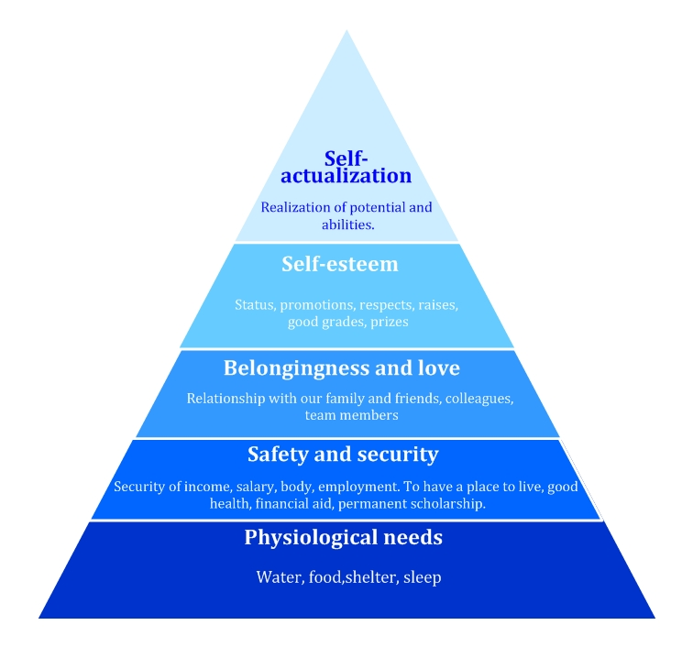
Maslow's hierarchy of needs is often shown in the shape of a pyramid: basic needs at the bottom and the most complex need (need for self-actualization) at the top. Maslow himself has never drawn a pyramid to describe these levels of our needs; but the pyramid has become the most known way to represent his hierarchy.

1. Physiological needs (e.g. food, water, shelter, sleep)
It includes the most basic needs for humans to survive, such as air, water and food. Maslow emphasized, our body and mind cannot function well if these requirements are not fulfilled.
These physiological needs are the most dominant of all needs. So if someone is missing everything in his/her life, probably the major motivation would be to fulfil his/her physiological needs rather than any others. A person who is lacking food, safety, love (also sex) and esteem, would most probably hunger for food (and also for money, salary to buy food) than for anything else.
If all the needs are unsatisfied, and the organism is then overruled by the physiological needs, all other needs may turn into the background. All capacities are put into the attendance of satisfying hunger. Any other things are forgotten or got secondary importance.
2. Safety and security (secure source of income, a place to live, health and well-being)
If the physiological needs are relatively well contented, new needs will appear, the so called safety needs. Safety needs refer to a person’s desire for security or protection. Basically everything looks less important than safety and protection (the physiological needs even sometimes). The healthy and fortunate adults in our culture are largely satisfied in their safety needs. The peaceful, sure, safety and unwavering society makes us feel in safety enough from criminal assaults, murder, unbelievable natural catastrophes, and so on. In that case people no longer have any safety needs as first-line motivators.
Meeting with safety needs demonstrated as a preference for insurance policies, saving accounts or job security, etc., we think about the lack of economic safety. Children have a greater need to feel safe. That is the reason why this level is more important for children.
Safety and security needs include: Personal security; Financial security; Health and well-being; Safety mesh against accidents, illnesses and their adverse impacts.
To tell the truth, in real dangers and traumas – like war, murder, natural catastrophes, criminal assault, etc. -, the needs for safety become an active, first-line and dominant mobilizer of human beings.
3. Belongingness and love (integration into social groups, feel part of a community or a group; affectionate relationships)
If both the physiological and the safety needs are fulfilled, the affection, love and belongingness needs come into prominence. Maslow claimed people need to belong and accepted among their social groups. Group size does not mean anything: social groups can be large or small. People need to love and be loved – both sexually and non-sexually – by others. Depending on the power and pressure of the peer group, this need for belonging may overbear the physiological and security needs.
Love needs involve giving and receiving affections (love is not synonymous with sex – sex is a physiological need). When they are unsatisfied, a person will immediately eliminate the lack of friends, peers and partner. Many people suffer from social nervousness, loneliness, social isolation and also clinical depression because of the lack of this love or belongingness factor.
4. Esteem (respect for a person as a useful, honourable human being)
In our society most people long for a stable and high valuation of themselves, for the esteem of others and for self-respect or self-esteem.
Esteem means being valued, respected and appreciated by others. Humans need to feel to be valued, such as being useful and necessary in the world. People with low self-esteem often need respect from others. Maslow divided two types of esteem needs: a ‘lower’ version and a ‘higher’ version. The ‘lower’ version of esteem is the need for respect from others: for example attention, prestige, status and loving their opinion. The ‘higher’ version is the need for self-respect: for example, the person may need independence, and freedom or self-confidence.
The most stable and therefore the healthiest self-esteem is based on respect from others. External fame or celebrity and unwarranted adulation won’t cause self-esteem, although you feel better for a while.
5. Self-actualization (individual’s desire to grow and develop to his or her fullest potential)
‘What humans can be, they must be.’ (Maslow, 1954)
Self-actualization reflects an individual’s desire to grow and develop to his/her fullest potential. People like opportunities, choosing his/her own versions, challenging positions or creative tasks. Maslow described this level as the ‘need to accomplish everything that one can, to become the most that one can be’. Maslow believed that people must overcome their other needs – described above -, not only achieve them. At this level, individual differences are the largest.
As each level is adequately satisfied, we are then motivated to satisfy the next level in the hierarchy, always new and higher needs are coming. This is what we mean, when the basic human needs are drawn like a pyramid, a hierarchy. Life experiences, including divorce and loss of job, may cause an individual to fluctuate between levels of the hierarchy. These five different levels were further sub-categorised into two main groups: deficiency and growth needs.
Deficiency needs – The very basic needs for survival and security.
These needs include:
• physiological needs
• safety and security needs
• social needs – belongingness and love
• esteem needs
It may not cause a physical indication if these ‘deficiency needs’ are not fulfilled, but the individual will feel anxious and tense. So the most basic level of needs must be fulfilled before a person wants to focus on the secondary or higher level needs.
Growth needs – Personal growth and fulfilment of personal potential.
These needs include:
• self-actualisation needs

This hierarchy is not as rigid as we may have implied. For example, there are some humans for whom self-esteem or self-actualization seems to be more important than love or belonging. The popularity of this theory of motivation rooted in its simplicity and logic.
Alderfer – ERG theory: Existence needs, relatedness needs and growth needs
Alderfer (Furnham, 2008) distinguished three steps or classes of needs: existence, relatedness and growth. Maslow’s physiological and safety needs belong together to existence needs. Relatedness can be harmonised to belongingness and esteem of others. Growth is the same as Maslow’s self-esteem plus self-actualization. Both Maslow and Alderfer tried to describe how these needs, these stages of needs become more or less important to individuals.
• Existence needs: These include needs for basic material necessities. In short, it includes an individual’s physiological and physical safety needs.
• Relatedness needs: Individuals need significant relationships (be with family, peers or superiors), love and belongingness, they strive toward reaching public fame and recognition. This class of needs contain Maslow’s social needs and external component of esteem needs.
• Growth needs: Need for self-development, personal growth and advancement form together this class of need. This class of needs contain Maslow’s self-actualization needs and intrinsic component of esteem needs.
Alderfer agreed with Maslow that unsatisfied needs motivate individuals. Alderfer also agreed that individuals generally move up the hierarchy in satisfying their needs; that is, they satisfy lower-order before higher-order needs. As lower-order needs are satisfied, they become less important, but Alderfer also said: as higher-order needs are satisfied they become more important. And it is also said that under some circumstances individuals might return to a lower need. Alderfer thought that individuals multiply the efforts invested in a lower category need when higher categorized needs are not consequent.
Adams' equity theory
The equity theory states that people are motivated if they are treated equitably, and receive what they consider fair for their effort and costs.
The theory was suggested by Adams (1965) and is based on Social Exchange theory.
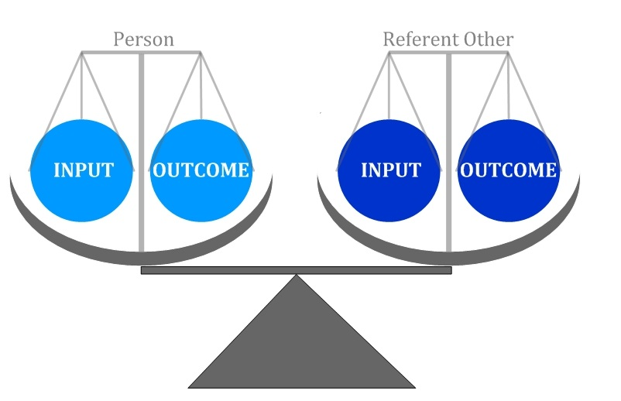
According to this theory, people compare their contribution to work, costs of their actions and the benefits that will result to the contribution and benefits of the reference person. If people perceive that the ratio of their inputs-outputs to the ratio of referent other's input-output is inequitable, then they will be motivated to reduce the inequity (Figure 5).

At the workplace the workers put inputs into the job, such as education, experience, effort, energy, and expect to get some outcomes such as salary, reward, promotion, verbal recognition, and interesting and challenging work each in equal amounts (Figure 6).

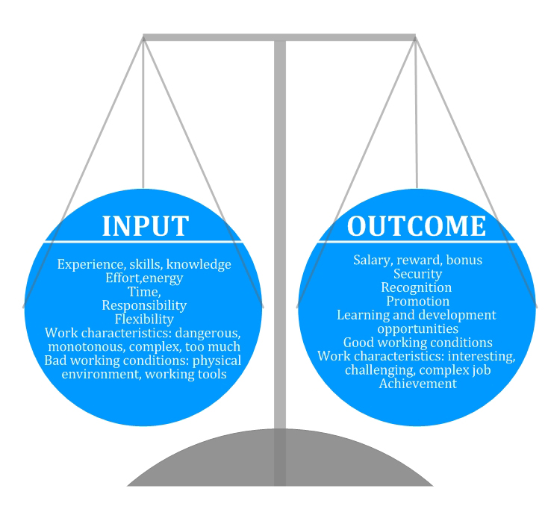
The equity theory works not just in the workplace, but at school as well. For example, when for the same oral exam performance two students get different marks, then inequity exists. In this case, the student who gets the worse mark may lose his/her motivation to learn (reduce his/her efforts), or persuade the teacher to give him/her a better mark, or change the perception of the reference person's performance ("I did not know everything, but my classmate could answer all the questions"). At the school it can demotivate students if someone who never studies or who never performs better than the others always gets good mark. The greater the inequity the greater the distress an individual feels, which will motivate the endeavour to make the outcomes and the inputs equal compared to the reference person.
When inequity exists, a person might…
• reduce his/her inputs, efforts, quantity or quality of his/her work
• try to increase his/her outputs (ask for better mark, or pay raising)
• adjust his/her perception of reference person or his/her outcomes or inputs (re-evaluate his/her or the reference person's effort or outcome)
• change the reference person
• quit the situation.

1.6.4 Absenteeism Rate
Absenteeism is the term generally used to pass on to rash employee absences from the workplace. Many causes of absenteeism are legal personal illness or family issues for example but absenteeism also can often be traced to other factors such as a reduced work environment or workers who are not devoted to their jobs. If such absences become extreme they can have a critically adverse crash on a business’s operations and finally its success.
Absence measurement is necessary in order for management to evaluate between person absence and departmental absences. Measuring absence is serious to recognize the different patterns of employee absence and aim the variables moving it. There are different ways to calculate absenteeism the most typically used is the lost time rate formula and the person frequency formula.
Absenteeism rate = Number of Man days lost *100
Individual frequency = number of absent employees/average number of employees*100
Types of absenteeism : Absenteeism are classified in to four types
-Authorized Absenteeism
If and employee absent himself from work by taking permission form his better and applying for leave.
-Unauthorized Absenteeism
If an employee absent himself from work without informing or taking permission and without applying for leave.
-Willful Absenteeism
If an employee absents himself from duty willfully.
-Absenteeism caused by circumstances beyond one’s control
If an employee absents himself from duty owing to the situation past his control likes accidents or infection.
Causes for Absenteeism:
In order to recognize the causes and amount of absenteeism proper report should be kept in every section for various causes of absenteeism such as age sex days of the week and classes of jobs by each division. Generally following reasons are attributable for absenteeism at work
Nature of the work, Poor working conditions , Absence of regular leave arrangements , Accidents ,Poor control ,Irregular transport facilities ,Lack of interest, Indebt ness, Alcoholism and gambling habits , Low level of wages , Miscellaneous causes

